**Dynamic config refresh**

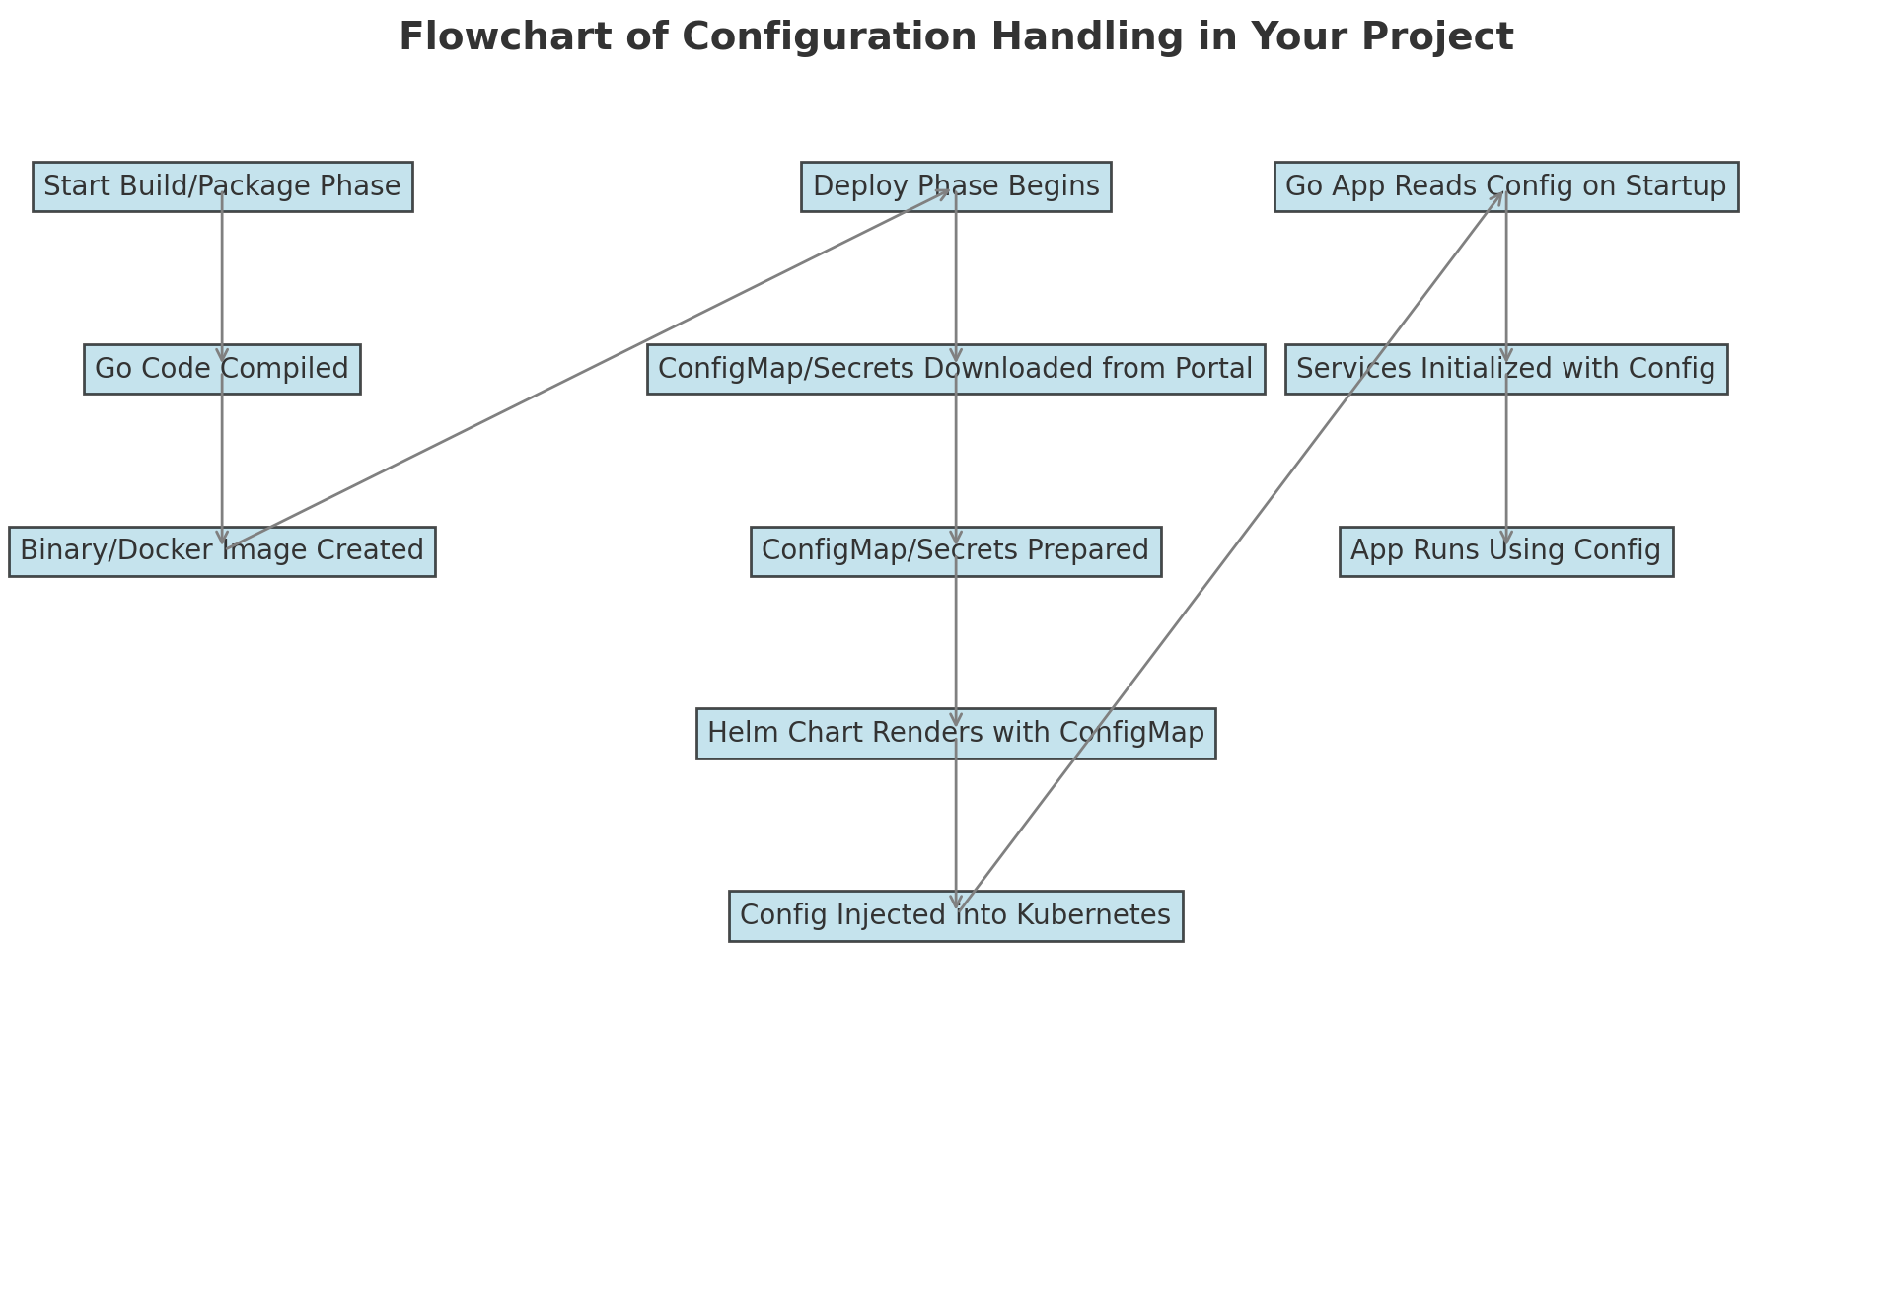

Static part

ConfigMaps are static once applied to the cluster.

Pods don’t automatically reload updated ConfigMaps without restarting.

Pods are immutable at runtime. They don’t pick up new ConfigMaps or Secrets dynamically.

Our app reads configurations only once at startup, binds them to the ConfigData struct, and uses them throughout its lifecycle.

So we have two concerns

1. ConfigMap Updates:

When ConfigMaps change, Kubernetes does not automatically reload them into running pods.

Pods must be restarted (via redeployment) to apply the updated configuration.

1. Service Initialization:

Components like Kafka consumers, or other components are initialized once during app startup.

Any change in configurations requires reinitializing these components, which requires restarting the app.

solution:

1. Instead of using configData struct, have the app always fetch the latest configs. We will need to implement some sort of a file watcher that will look for changes in config.json(on a trigger of some command / helm-diff) and load those into the app at runtime.
   1. Some sort of common registry is needed where all the components in our system subscribe to and then we poll for changes in the config portal / manually trigger an api that pulls the changes and the subsequent subscribed components take up the updated value at runtime.

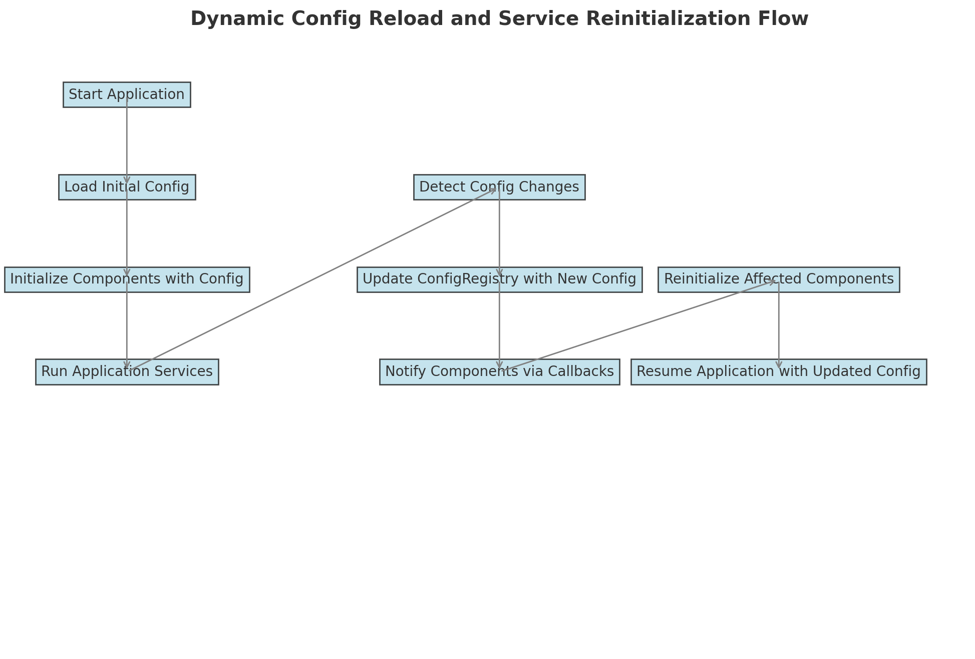

**Ingress Issue**

1. Place configs at gateway level ?